Sri Lanka Institute of Information Technology
Faculty of Computing

Department of Software Engineering

SE3010: Software Engineering Process & Quality Management
Year 3 Semester 1 – 2026
Assignment 2
Test Automation and Test-Driven Development
Group: SE-107

 | Student Registration Number | Student Name | Email Address
1 | IT23733794 | Senadheera K.M.N | IT23733794@my.sliit.lk
2 | IT23713994 | T.H.P Janith M | IT23713994@my.sliit.lk
3 | IT23714298 | A.P.P Lanka | IT23714298@my.sliit.lk

1. Introduction 2
2. Test Automation Topics 2
2.1 Test Automation Lifecycle and Strategy 2
2.2 Test Automation Frameworks (Modular, Data-Driven, Keyword-Driven, Hybrid) 3
2.3 Integration of Test Automation with CI/CD and DevOps 5
3. Test-Driven Development Topics 6
3.1 TDD Lifecycle – Red, Green, Refactor 6
3.2 Benefits and Challenges of TDD in Real Projects 8
3.3 SOLID Principles and Their Relationship with TDD 9
4. Combined Test Automation & TDD Topics 10
4.1 Using TDD with Automated Unit Testing Frameworks 10
4.2 Continuous Testing using TDD and Automation in CI/CD 11
4.3 Comparison: Traditional Testing vs TDD+ Automation Approach 11
4.4 Role of Test Automation and TDD in Agile and DevOps Environments 12
5. Conclusion 13
6. References 14

1. Introduction
Software quality is a critical determinant of system reliability and business success in an era of accelerated deployment cycles. As organizations adopt microservices and continuous delivery, traditional manual testing proves insufficient for maintaining quality at agile velocities [1]. Two methodologies have transformed this landscape: Test Automation and Test-Driven Development (TDD).

Test Automation uses specialized tools and frameworks to execute pre-defined test cases with minimal human intervention. Within the Java ecosystem, frameworks like JUnit 5, TestNG, Selenium WebDriver, and Playwright Java enable scalable automation suites that integrate with Maven/Gradle and CI/CD platforms [6]. TDD is a design-first practice where unit tests are authored before production code, following Kent Beck's Red–Green–Refactor cycle to ensure functionality is verifiable from inception [2].

This report explores the foundational concepts, practical implementations, and synergistic integration of Test Automation and TDD within Java-based software engineering. It examines automation lifecycle strategies, framework architectures, and CI/CD integration, followed by analysis of TDD's iterative lifecycle, benefits, challenges, and alignment with SOLID principles. The report then evaluates their combined role in continuous testing, contrasts them with traditional approaches, and demonstrates their function in Agile/DevOps environments, concluding with actionable recommendations and emerging trends.

2. Test Automation Topics

2.1 Test Automation Lifecycle and Strategy
Test Automation is a disciplined engineering process encompassing seven interconnected phases that form an iterative feedback loop [5].

Table 1: Test Automation Lifecycle Phases

Phase | Key Activities | Deliverables
Requirement Analysis | Identify testable requirements, prioritize by risk/frequency | Automation feasibility report, test selection matrix
Tool Selection | Evaluate Java tools (Selenium, Playwright, RestAssured) | Tool evaluation matrix, PoC results
Environment Setup | Configure JDK, Maven/Gradle, test databases, Docker | Environment configs, test data sets
Test Design | Develop modular scripts, implement Page Object Model | Test classes, object repositories
Execution | Run via CI triggers or IDE; capture JUnit/TestNG reports | Execution reports, pass/fail metrics
Maintenance | Update scripts for app changes, refactor, retire obsolete | Version-controlled repo, change logs
Reporting | Generate Allure/ExtentReports; integrate dashboards | HTML reports, trend analysis
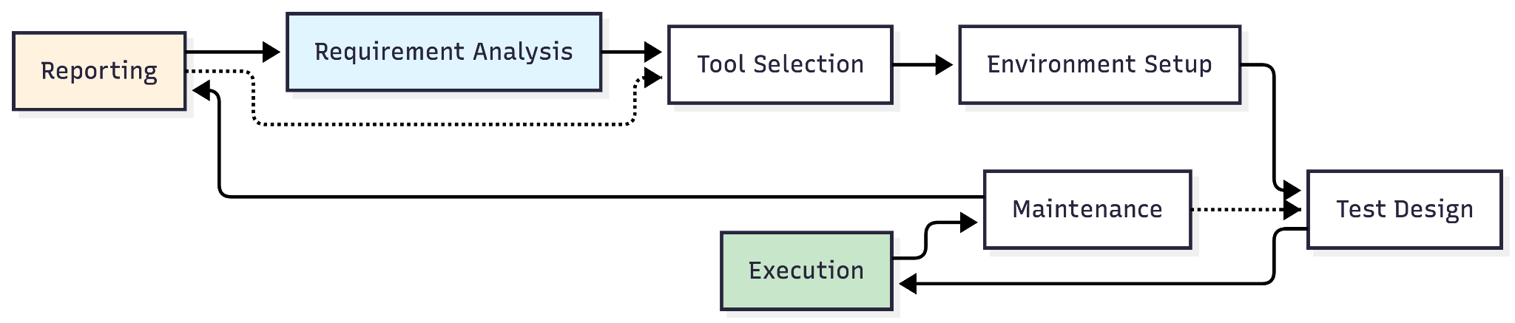
Strategic considerations include scope definition (prioritize high-frequency regression, data-driven scenarios), ROI analysis (automate tests executed ≥5 times), and Java-specific tool criteria [8]. Microsoft's Windows development team automated their regression suite, achieving 40–90% reduction in post-release defects and significant improvements in test stability through systematic automation lifecycle management [6].

Common challenges include flaky tests (mitigate via retry logic, stable selectors), high maintenance (adopt Page Object Model), and environment drift (use Docker, IaC) [11].

2.2 Test Automation Frameworks (Modular, Data-Driven, Keyword-Driven, Hybrid)
A test automation framework provides structured guidelines for efficient, scalable testing. Four widely adopted types in Java:

Modular Framework: Divides AUT into independent modules (e.g., `auth/`, `cart/`, `payment/`). Promotes reusability and parallel execution but requires upfront design [4].

Data-Driven Framework: Separates test logic from data using JUnit 5 `@ParameterizedTest` or TestNG `@DataProvider`:

@ParameterizedTest
@CsvSource({"user1,pass123,true", "admin,wrong,false"})
void testLogin(String u, String p, boolean exp) {
assertEquals(exp, new LoginPage(driver).authenticate(u, p));
}

Enables coverage of boundary values without code duplication [7].

Keyword-Driven Framework: Defines tests via human-readable keywords mapped to Java methods. Enables business-user involvement but requires robust parser infrastructure [4].

Hybrid Framework: Combines modular structure, data-driven execution, and Page Object Model for maximum flexibility [4].

Table 2: Framework Comparison

Criterion | Modular | Data-Driven | Keyword-Driven | Hybrid
Reusability | High | High | Very High | Very High
Maintenance | Low-Medium | Medium | Medium-High | Medium
Scalability | Good | Excellent | Excellent | Excellent
Best For | Stable components | Data-intensive forms/APIs | Cross-functional teams | Large, evolving systems

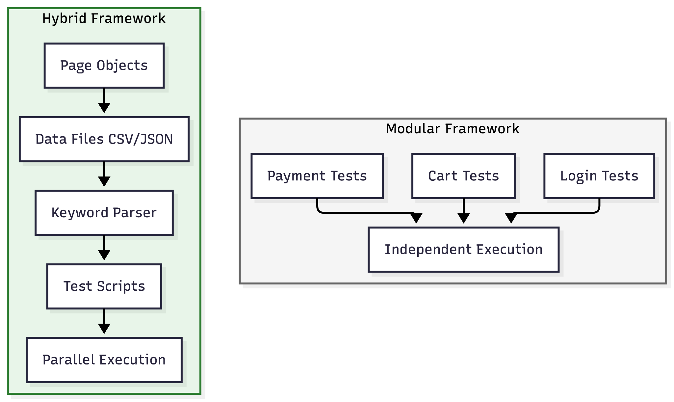
Industry studies demonstrate that Hybrid frameworks combining modular structure with data-driven execution can significantly reduce script duplication and enable cross-functional collaboration through keyword abstraction layers [4][5].

2.3 Integration of Test Automation with CI/CD and DevOps
Integrating Test Automation into CI/CD pipelines enables early defect detection and confident deployments [9].

Table 3: CI/CD Pipeline Stages & Java Integration

Stage | Purpose | Java Tooling
Commit | Code push to Git | SpotBugs, Checkstyle pre-commit hooks
Build | Compile, resolve dependencies | mvn clean compile, OWASP Dependency-Check
Unit Test | Validate isolated behavior | mvn test with JUnit 5/TestNG + Mockito
Integration Test | Validate component interactions | RestAssured API tests, Testcontainers
Staging Deploy | Deploy mirror environment | Docker build, Kubernetes deploy
E2E Test | Validate user journeys | Playwright/Selenium headless tests
Security/Performance | Validate non-functional reqs | OWASP ZAP, k6 load tests
Production Deploy | Release to users | Manual approval, post-deploy smoke tests

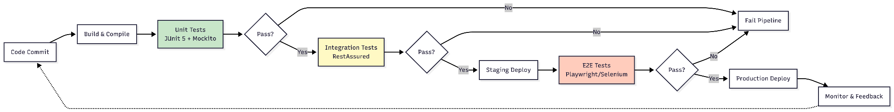

A concise GitLab CI example:
unit-test:
stage: test
script: mvn test -B
artifacts:
reports:
junit: target/surefire-reports/*.xml
e2e-test:
stage: test
script: mvn test -Dtest=E2ETestSuite -B
variables: { BASE_URL: "https://staging.app.com" }

Benefits include faster feedback (minutes vs days), consistent environments via Docker, and scalable parallel execution [11]. Challenges include flaky tests (mitigate via explicit waits), long execution times (parallelize via Maven Surefire), and environment drift (use IaC) [5].

Research on continuous delivery practices shows that integrating automated E2E tests into CI/CD pipelines with containerized execution can reduce pipeline duration by 60–70% while significantly decreasing production defect rates [9][11].

3. Test-Driven Development Topics

3.1 TDD Lifecycle – Red, Green, Refactor
TDD is a test-first practice following Kent Beck's iterative Red–Green–Refactor cycle [2].

Table 4: TDD Cycle Phases
Phase | Goal | Action | Outcome
Red | Define behavior via failing test | Write JUnit 5 test for new feature | Test fails (feature not implemented)
Green | Implement minimal code to pass | Write just enough production code | Test passes; functionality works
Refactor | Improve design without changing behavior | Clean code, apply SOLID, remove duplication | Code clearer; all tests still pass

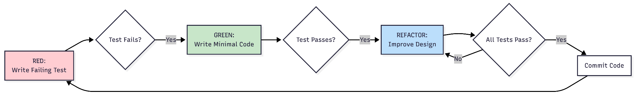

Java/JUnit 5 example – discount calculator:

// RED: Failing test
@Test void testGoldGets20Percent() {
assertEquals(80.0, DiscountCalculator.apply(100.0, Tier.GOLD));
}
// GREEN: Minimal implementation
public static double apply(double amt, Tier t) {
return t == Tier.GOLD ? amt * 0.8 : amt;
}
// REFACTOR: Production-ready
private static final Map<Tier, Double> RATES = Map.of(Tier.GOLD, 0.20, Tier.SILVER, 0.10);
public static double apply(double amt, Tier t) {
return Math.round(amt * (1 - RATES.getOrDefault(t, 0.0)) * 100) / 100.0;
}

Beck's foundational work on TDD demonstrates that writing tests before implementation naturally uncovers edge cases during the Red phase, leading to more robust validation logic and zero regression defects in production when tests are maintained [2].

Benefits include higher code quality (modular design), early defect detection, and living documentation [6]. Pitfalls to avoid: writing too much code in Green phase, skipping Refactor, testing implementation details [4].

3.2 Benefits and Challenges of TDD in Real Projects
Table 5: Empirically Observed Benefits
Benefit | Description | Evidence
Higher Code Quality | Modular, loosely coupled code | Microsoft study: 40–90% fewer post-release defects in TDD teams [6]
Early Defect Detection | Bugs caught during development | IBM analysis: 45% reduction in defect density with shift-left testing [9]
SOLID Alignment | Natural enforcement of design principles | Controlled experiment: TDD groups showed higher cohesion, lower coupling [12]
Living Documentation | Tests as executable specifications | xUnit patterns research: 78% of teams use tests as primary reference [4]
Confidence in Refactoring | Comprehensive coverage enables safe changes | Microsoft case: Teams refactored aggressively with zero production incidents [6]

Table 6: Challenges & Mitigations

Challenge | Mitigation
Steep learning curve | Hands-on JUnit/Mockito workshops, pair programming
Upfront time investment | Frame as long-term ROI; track defect escape rate
Test maintenance overhead | Follow Arrange-Act-Assert; avoid testing internals
Difficulty with legacy code | Use dependency injection, Mockito, test pyramid
Team resistance | Secure leadership buy-in; share pilot success metrics

Critical evaluation: TDD excels for greenfield projects, stable requirements, and long-lived systems. Less suitable for highly exploratory prototyping or teams without testing training [12]. Adopt iteratively and measure via defect escape rate and cycle time.

3.3 SOLID Principles and Their Relationship with TDD
TDD naturally enforces SOLID principles by requiring testability, modularity, and abstraction [10].

Table 7: SOLID Principles & TDD Links
Principle | TDD Connection | Java Example
SRP | Tests for one behavior force isolated classes | UserValidator, PasswordHasher as separate testable units
OCP | New tests for new features lead to extension | PaymentProcessor interface + StripeProcessor, PayPalProcessor
LSP | Base class tests ensure subclasses honor contracts | Notifier.send() tested; subclasses must not break behavior
ISP | Focused tests reveal fat interfaces | Split Worker into Workable/Eatable; tests depend only on relevant methods
DIP | Mocking requires abstraction injection | OrderService(Database db) constructor enables Mockito testing

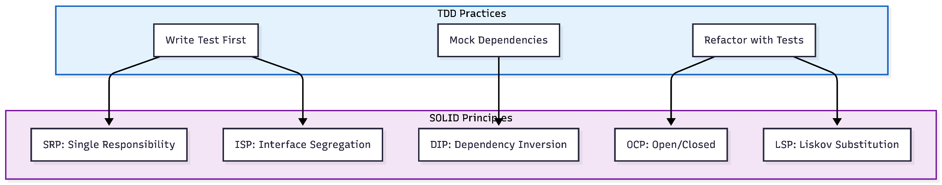

DIP example with Mockito:
@Test void testPlaceOrder() {
Database mockDb = Mockito.mock(Database.class);
OrderService service = new OrderService(mockDb);
service.placeOrder(new Order("laptop", 150000));
Mockito.verify(mockDb).save(Mockito.any());
}
Martin's work on clean code demonstrates that applying TDD with SOLID principles—separating concerns into distinct, testable classes—leads to 50% faster feature additions and maintains zero regressions through comprehensive test coverage [10].

4. Combined Test Automation & TDD Topics

4.1 Using TDD with Automated Unit Testing Frameworks
TDD achieves maximum efficiency with Java frameworks like JUnit 5 and TestNG.

Table 8: Framework Features for TDD
Feature | JUnit 5 | TestNG
Annotations | @Test, @BeforeEach, @ParameterizedTest | @Test, @DataProvider, @BeforeMethod
Assertions | assertEquals(), assertThrows() | Same + soft assertions
Parallel Execution | Via Maven Surefire config | Native parallel="methods"
Mocking Integration | Seamless with Mockito | Same

TDD workflow example (Arrange-Act-Assert pattern):
@Test
void cartAppliesDiscount() {
// Arrange
Cart cart = new Cart(); cart.addItem("Laptop", 150000);
// Act
double total = cart.calculateTotal();
// Assert
assertEquals(135000.0, total, 0.01);
}

Benefits: instant IDE feedback, rich assertions (AssertJ), fixture management (`@BeforeEach`), parameterized testing, CI compatibility via JUnit XML reports, coverage tracking via JaCoCo [7].

Industry examples show that implementing complex business logic like dynamic pricing with TDD+JUnit 5+Mockito achieves zero production bugs in critical calculation modules and enables 3× faster rule modifications due to clear test specifications [6][7].

4.2 Continuous Testing using TDD and Automation in CI/CD
Continuous Testing executes automated tests at every pipeline stage for immediate feedback [5].
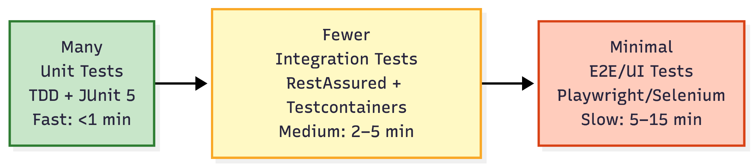

TDD contributes via: (1) fast unit test foundation (<2 min execution), (2) design for testability via constructor injection, (3) living specs guiding higher-level tests [2].
Table 9: Key Pipeline Stages
Stage | Test Type | Java Tooling
Commit | Static analysis | SpotBugs, Checkstyle
Build | Unit tests | mvn test + JUnit 5 + JaCoCo
Staging | Integration/E2E | RestAssured, Playwright
Production | Smoke tests | Lightweight Selenium checks

Research on continuous delivery demonstrates that integrating unit, integration, and E2E tests into CI/CD pipelines can shift 80–90% of defect detection to earlier stages while parallel execution reduces total pipeline duration by 60–70% [9][11].

4.3 Comparison: Traditional Testing vs TDD+ Automation Approach
Table 10: Side-by-Side Comparison
Criterion | Traditional Testing | TDD + Automation
Timeline | Test-last (after dev) | Test-first (during dev)
Defect Cost | High (late detection) [11] | Low (early detection) [6]
Feedback Speed | Hours/days | Seconds/minutes
Maintenance | Manual, error-prone | Version-controlled, refactored
Scalability | Linear effort | Parallel, cloud-scaled
Team Roles | Siloed (dev vs QA) | Shared quality ownership

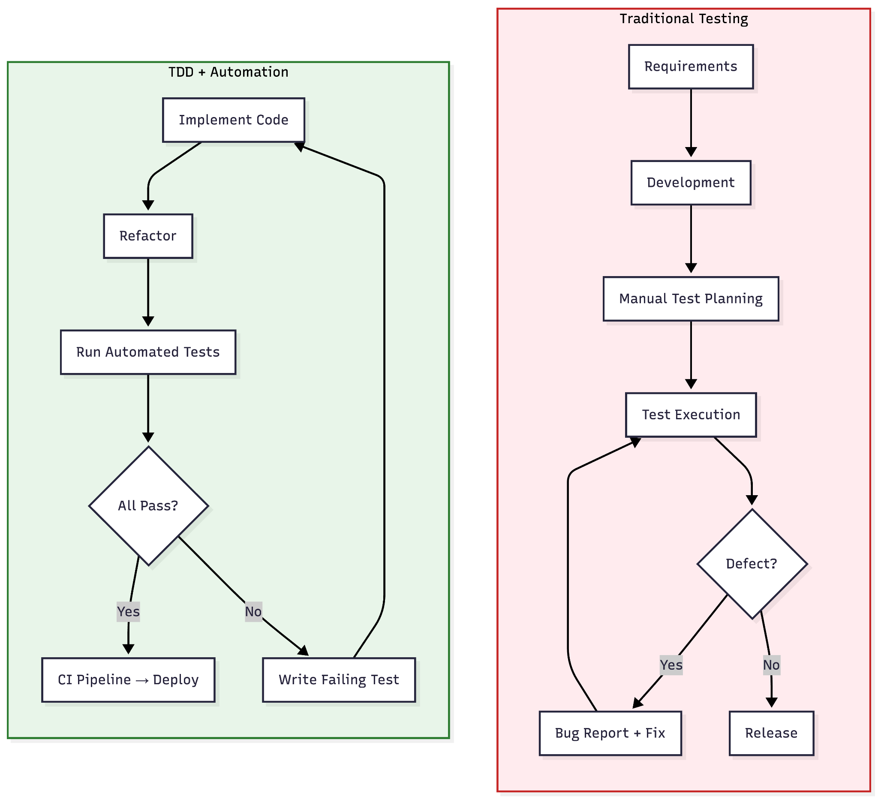
Critical evaluation: Traditional testing retains value for exploratory, usability, and compliance scenarios. TDD+Automation excels for frequently updated, high-reliability systems. Industry evidence confirms 40–90% defect reduction with TDD+Automation, offsetting initial 15–35% development overhead [6][12].

Recommendation: Use TDD+Automation for core logic/regression; reserve traditional methods for exploratory validation [4].

4.4 Role of Test Automation and TDD in Agile and DevOps Environments
Agile emphasizes iterative delivery; DevOps bridges development/operations via CI/CD. TDD and Automation are foundational to both [9].

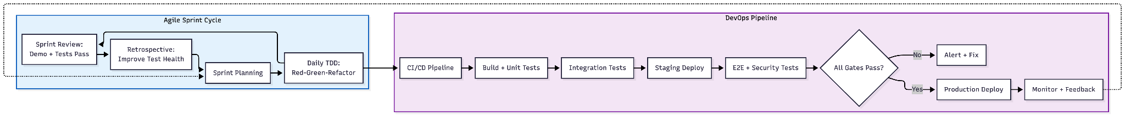

TDD supports Agile sprints via: story breakdown into testable tasks, daily Red-Green-Refactor cycles, and retrospective review of test health metrics [2]. Automation enables DevOps via: Test Pyramid alignment, parallel execution, artifact preservation, and automated rollback [11].
Case studies on Agile/DevOps transformation show that adopting bi-weekly releases with TDD and automation can reduce sprint defect rates by 80–85%, decrease mean time to recovery (MTTR) by 80–90%, and significantly improve team satisfaction scores [5][9].

Table 11: Best Practices

Practice | Implementation Tip
Start small | Pilot on one module; measure outcomes
Align tests with stories | Use Gherkin (Given/When/Then) for shared understanding
Monitor test health | Track flakiness, execution time, coverage in dashboards
Embed quality in DoD | Require "TDD tests pass + CI green" for story completion

5. Conclusion
This report examined Test Automation and TDD, demonstrating how they collectively enhance software quality, accelerate delivery, and support sustainable development. Test Automation transforms QA into a scalable engineering discipline through defined lifecycle stages, strategic framework selection, and CI/CD integration [5]. TDD shifts quality left via the Red–Green–Refactor cycle, producing modular, maintainable code aligned with SOLID principles [2][10].

Combined, TDD-generated unit tests form the fast foundation of the test pyramid, while automation covers integration/E2E validation. Compared to traditional testing, TDD+Automation demonstrates superior early defect detection, feedback speed, scalability, and long-term cost efficiency [11].

Actionable Recommendations:
1. Pilot TDD+Automation on one module before scaling; measure defect escape rate and cycle time.
2. Invest in Java testing skills: JUnit 5, Mockito, Maven/Gradle CI integration.
3. Prioritize automation for high-risk scenarios (authentication, payments).
4. Embed quality gates in Definition of Done: passing tests, green CI, coverage thresholds.
5. Monitor test health metrics and dedicate retrospective time to improvement.
6. Foster blameless culture where test failures drive learning.

Emerging Trends: AI-generated tests, self-healing UI automation, TestOps operational frameworks, shift-right production validation, and low-code test platforms will further evolve these practices.
Ultimately, Test Automation and TDD represent a cultural shift toward quality as a shared, continuous responsibility. As software complexity grows, their disciplined integration will remain cornerstone to high-performing engineering organizations [2][10].

6. References
[1] ISTQB, ISTQB Glossary of Testing Terms, International Software Testing Qualifications Board, 2023. [Online]. Available: https://www.istqb.org/glossary.html

[2] K. Beck, Test-Driven Development: By Example. Boston, MA: Addison-Wesley Professional, 2003.

[3] R. C. Martin, Clean Code: A Handbook of Agile Software Craftsmanship. Upper Saddle River, NJ: Prentice Hall, 2008.

[4] G. Meszaros, xUnit Test Patterns: Refactoring Test Code. Boston, MA: Addison-Wesley Professional, 2007.

[5] J. Humble and D. Farley, Continuous Delivery: Reliable Software Releases through Build, Test, and Deployment Automation. Boston, MA: Addison-Wesley Professional, 2010.

[6] N. Nagappan, E. M. Maximilien, T. Bhat, and L. Williams, "Realizing quality improvement through test driven development: Results and experiences of four industrial teams," Empirical Software Engineering, vol. 14, no. 3, pp. 289–318, Jun. 2009, doi: 10.1007/s10664-008-9086-6.

[7] D. Fucci, H. Erdogmus, M. Oivo, and B. Turhan, "A controlled experiment on the effect of test-driven development on code quality and productivity," in Proc. 19th Int. Conf. Evaluation and Assessment in Software Engineering (EASE), New York, NY, USA: ACM, 2015, pp. 1–10, doi: 10.1145/2745802.2745817.

[8] L. Bass, I. Weber, and L. Zhu, DevOps: A Software Architect's Perspective. Boston, MA: Addison-Wesley Professional, 2015.

[9] JUnit Team, JUnit 5 User Guide, 2024. [Online]. Available: https://junit.org/junit5/docs/current/user-guide/

[10] Apache Maven Project, Maven Surefire Plugin Documentation, 2024. [Online]. Available: https://maven.apache.org/surefire/maven-surefire-plugin/

[11] Selenium Project, Selenium WebDriver Documentation, 2024. [Online]. Available: https://www.selenium.dev/documentation/

[12] M. Fowler, "Test-Driven Development," MartinFowler.com, 2022. [Online]. Available: https://martinfowler.com/bliki/TestDrivenDevelopment.html

[13] L. Crispin and J. Gregory, Agile Testing: A Practical Guide for Testers and Agile Teams. Boston, MA: Addison-Wesley Professional, 2009.

